附： SCI/EI检索证明模板
一、检索证明模板：
SCI检索:
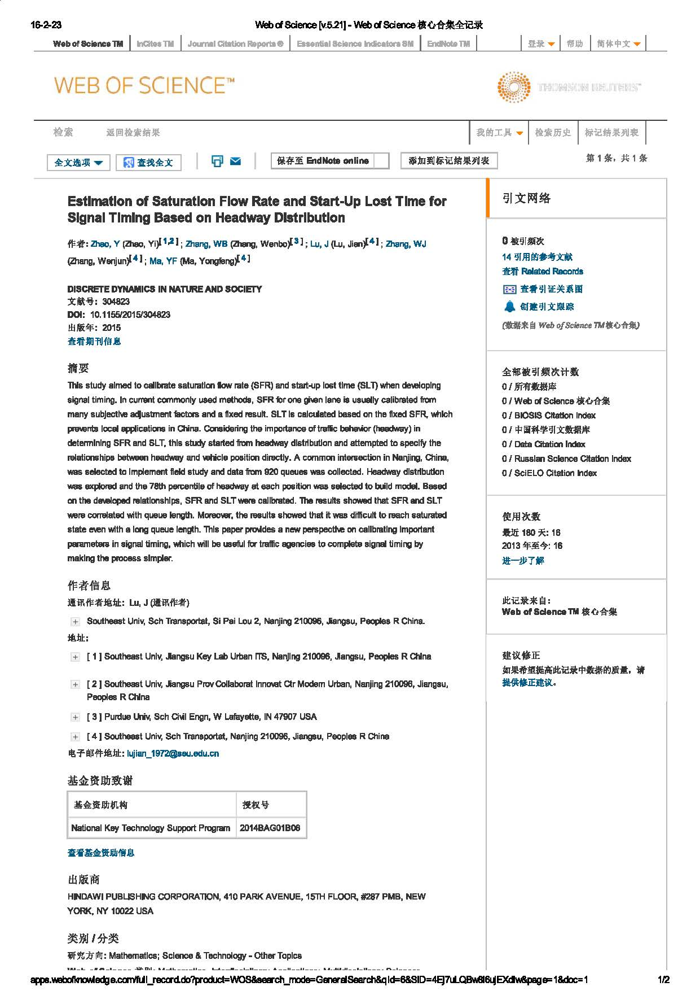
EI检索:
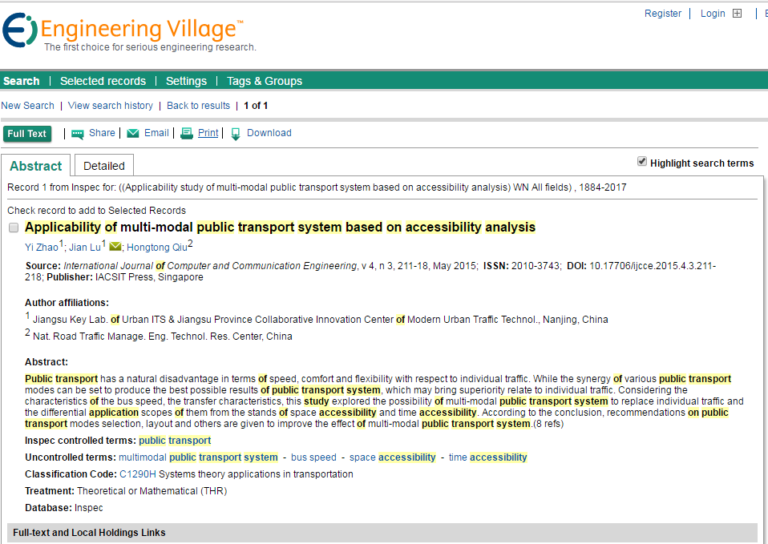

二、检索网址链接模板：
SCI检索:
http://apps.webofknowledge.com/full_record.do?product=WOS&search_mode=GeneralSearch&qid=1&SID=3ApnKQGIYBuhzN71hwi&page=1&doc=1
EI检索:
https://www.engineeringvillage.com/search/doc/detailed.url?SEARCHID=14b3a57eM80ceM45a5M8867M7574f80ab281&DOCINDEX=1&database=1&pageType=quickSearch&searchtype=Quick&dedupResultCount=&format=quickSearchDetailedFormat&usageOrigin=recordpage&usageZone=abstracttab

