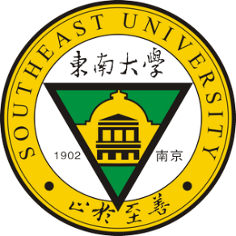
Southeast Symposium of
Recent Developments in Geotechnics
with Themed Workshops on Offshore Geotechnics
8th – 9th July 2017
GEO Symposium
Southeast University, Nanjing, P.R. China

Participation form
(To be returned by 15thMay 2017 by emailing to geo@pub.seu.edu.cn)

Title: Dr. / Ing. / Prof. / Mr. / Ms. (please delete as appropriate)
Surname:
First Name:
Academic position：
Organisation:
Contact address:
Contact number:
Email address:
Date of arrival:
Date of departure:
Q1, Would you like to give a presentation?
YES / NO
If yes, please provide the title of your presentation:

Q2, Do you have special diet requirement?
YES / NO
If yes, please provide details:

Q3, Are you interested in recruitment opportunity at southeast University?
YES / NO
If yes, please provide details on your area of research, academic career, publications, markers of esteem, and any other relevant information

Q4, Would you like to apply the travel grant?
YES / NO
If yes, please describe your background, motivation to attend the event, how you can benefit from the event, and any other relevant information

Q5. Please use this space to give any other relevant information

Printed Name:
Signature:

Date:

